# Project Profile

**Project Title :** ATM Simulation System

**Front End Tool :** Tkinter

**Back End Tool :** SQLite Server

**Project Platform :** Python 3.9

**Project Guide :** Mr. Yusuf

**Developed By :** Okedokun Olajide

Ola Oluwatoyosi

Ubah Samuel

# WHAT IS ATM

An ATM is an electronic device which allows a bank’s customer to make financial transactions in a public space & check their account balance at any time without the need for a human teller.

* The customer is identified by a plastic ATM card with a magnetic stripe or a plastic smartcard with a chip.
* Services available through an ATM  Withdraw cash.
  + Transfer money between accounts.
  + Obtain account balance.
  + Make deposits of cash and checks

# PREFACE

Case study (Software Engineering) is a long establishment method of organizing, learning, so as to encourage coordination of Subject areas, it aims at closer integration of theory and practical give fundamental basic for student learning and produce, more practical techniques. Project method in common with other students centered technique help to develop market survey, planning decision making on for example and identifying the critical integrated industrial process for producing equipment, a component or a model of process.

# ABSTRACT:

This report attempts to understand the design of an Automated Teller Machine (ATM) system, a device used by bank customers to process account transactions. Typically, a user inserts into the ATM a special plastic card that is encoded with information on a magnetic strip. The strip contains an identification code that is transmitted to the bank's central computer by modem. To prevent unauthorized transactions, a personal identification number (PIN) must also be entered by the user using a keypad. The computer then permits the ATM to complete the transaction; most machines can dispense cash, accept deposits, transfer funds, and provide information on account balances. Banks have formed cooperative, nationwide networks so that a customer of one bank can use an ATM of another for cash access. Some ATMs will also accept credit cards for cash advances. The first ATM was installed in 1969 by Chemical Bank at its branch in Rockville Centre, New York. A customer using a coded card was dispensed a package containing a set sum of money.

# PYHTON:

Python is an interpreted, high-level, general-purpose programming language. Created by Guido van Rossum and first released in 1991, Python has a design philosophy that emphasizes code readability, notably using significant whitespace. It provides constructs that enable clear programming on both small and large scales. Van Rossum led the language community until July 2018. Python is dynamically typed and garbage-collected. It supports multiple programming paradigms, including procedural, object-oriented, and functional programming. Python features a comprehensive standard library, and is referred to as "batteries included". Python interpreters are available for many operating systems. CPython, the reference implementation of Python, is open-source software and has a community-based development model. Python and CPython are managed by the non-profit Python Software Foundation.



# TKINTER GUI:

Python offers multiple options for developing GUI (Graphical User Interface). Out of all the GUI methods, tkinter is most commonly used method.

It is a standard Python interface to the Tk GUI toolkit shipped with Python. Python with tkinter outputs the fastest and easiest way to create the GUI applications. Creating a GUI using tkinter is an easy task.

To create a tkinter:

* Importing the module – tkinter
* Create the main window (container)
* Add any number of widgets to the main window ➢ Apply the event Trigger on the widgets.

Importing tkinter is same as importing any other module in the python code.

Note that the name of the module in Python 2.x is ‘Tkinter’ and in Python 3.x is ‘tkinter’.

# PYCHARM IDE:

PyCharm is an integrated development environment (IDE) used in computer programming, specifically for the Python language. It is developed by the Czech company JetBrains. [6] It provides code analysis, a graphical debugger, an integrated unit tester, integration with version control systems (VCSes), and supports web development with Django. PyCharm is crossplatform, with Windows, macOS and Linux versions. The Community Edition is released under the Apache License,[7] and there is also Professional Edition with extra features, released under a proprietary license.



# SQLITE DATABASE:

SQLite is a [relational database management system](https://en.wikipedia.org/wiki/Relational_database_management_system) (RDBMS) contained in a [C](https://en.wikipedia.org/wiki/C_(programming_language)) [library](https://en.wikipedia.org/wiki/Library_(computer_science)). In contrast to many other database management systems, SQLite is not a [client–server](https://en.wikipedia.org/wiki/Client%E2%80%93server) database engine. Rather, it is embedded into the end program.

SQLite generally follows [PostgreSQL](https://en.wikipedia.org/wiki/PostgreSQL" \o "PostgreSQL) syntax. SQLite uses a dynamically and [weakly typed](https://en.wikipedia.org/wiki/Weakly_typed) SQL [syntax](https://en.wikipedia.org/wiki/Syntax) that does not guarantee the [domain integrity](https://en.wikipedia.org/wiki/Data_integrity#TYPES).

 This means that one can, for example, insert a string into a [column](https://en.wikipedia.org/wiki/Column_(database)) defined as an integer. SQLite will attempt to convert data between formats where appropriate, the string "123" into an integer in this case, but does not guarantee such conversions and will store the data as-is if such a conversion is not possible.

SQLite is a popular choice as [embedded database](https://en.wikipedia.org/wiki/Embedded_database) software for local/client storage in [application software](https://en.wikipedia.org/wiki/Application_software) such as [web browsers](https://en.wikipedia.org/wiki/Web_browser). It is arguably the most widely deployed [database engine](https://en.wikipedia.org/wiki/Database_engine), as it is used today by several widespread browsers, [operating systems](https://en.wikipedia.org/wiki/Operating_system), and [embedded systems](https://en.wikipedia.org/wiki/Embedded_system) (such as mobile phones), among others.  SQLite has [bindings](https://en.wikipedia.org/wiki/Language_binding) to many programming languages



**DETAIL OF CHAPTERS**

### 1.0 Introduction

### 1.1 Project Summary

### 1.2 Purpose

### 1.3 Scope

**2.0 Project Management**

#### 2.1 Project Planning and scheduling

#### 2.2 Project Development Approach

#### 2.3 Project Plan

**3.0 System Requirements Study**

#### 3.1 User Characteristics

#### 3.2 Hardware and Software Requirements

#### 3.3 Constraints

**4.0 System Analysis**

#### 4.1 Study of Current System

#### 4.2 Problem and Weaknesses of Current System

#### 4.3 Requirements of New System

#### 4.4 Feasibility Study

**5.0 Testing**

#### 5.1 The login page

#### 5.2 The Registration page

#### 5.3 The Transaction page

**6.0 Limitation and Future Enhancement**

**7.0 Conclusion**

# 1.0 Introduction

## 1.1 Project Summary

An automated teller machine (ATM) or automatic banking machine (ABM) is a computerized telecommunications device that provides the clients of a financial institution with access to financial transactions in a public space without the need for a cashier, human clerk or bank teller. On most modern ATMs, the customer is identified by inserting a plastic ATM card with a magnetic stripe or a plastic smart card with a chip that contains a unique card number and some security information such as an expiration date or CVVC (CVV). Authentication is provided by the customer entering a personal identification number (PIN).

## 1.2 Purpose

Using an ATM, customers can access their bank accounts in order to make cash withdrawals (or credit card cash advances) and check their account balances as well as purchase cellphone prepaid credit. If the currency being withdrawn from the ATM is different from that which the bank account is denominated in (eg: Withdrawing Japanese Yen from a bank account containing US Dollars), the money will be converted at a wholesale exchange rate. Thus, ATMs often provide the best possible exchange rate for foreign travelers and are heavily used for this purpose as well.

ATMs are known by various other names including Automated Transaction Machine, automated banking machine, cashpoint (in Britain),money machine, bank machine, cash machine, hole-in-the-wall, Banc mat (in various countries in Europe and Russia), Multi banc (after a registered trade mark, in Portugal), and

Any Time Money (in India)

## 1.3 Scope

The main purpose of the ATM division and information service is to provide the customers financial flexibility, worldwide acceptance and round-the clock convenience. Bank issues only VISA Credit Cards, the renowned Credit Card brand. Cardholders can purchase goods/services up to the credit limit and can reuse the credit facility upon repayment. Credit Card is a safer substitute to cash and is the major mode of payment worldwide. Standard Chartered Bank is the first to introduce the TAKA CREDIT CARD. The card is issued basically to a person’s name and the specific person can use the card in anywhere in Bangladesh. The business activity of Premier Bank Credit Card section is to keep the records of all sales and customers’ requests, the information of cardholders and reports them to necessary documents

# 2.0 Project management

In this chapter we will discuss about project planning and scheduling. Our goal is to establish a pragmatic strategy for controlling, tracking, and monitoring a complex technical project.

In project management following things must be done.

* Project Planning and Scheduling
* Risk Management
* Estimation

In Project planning and scheduling, Planning of the project is done. In scheduling different task are schedule according to the deadline of the project.

# 2.1 Project Planning and scheduling

Project planning must deals with the following things.

* **Project Complexity: -** Project complexity has a strong effect but is heavily influenced by past practitioner experience.
* **Project Size: -** As size increases the interdependency of elements also grow. Watch out for scope creep.
* **The degree of structural uncertainty: -** the degree to which requirements are solidified and the ease of functional decomposition. The purpose of project planning is to ensure that the end result is completed on time, within budget, and exhibits quality!

**2.2**

**Project development approach**

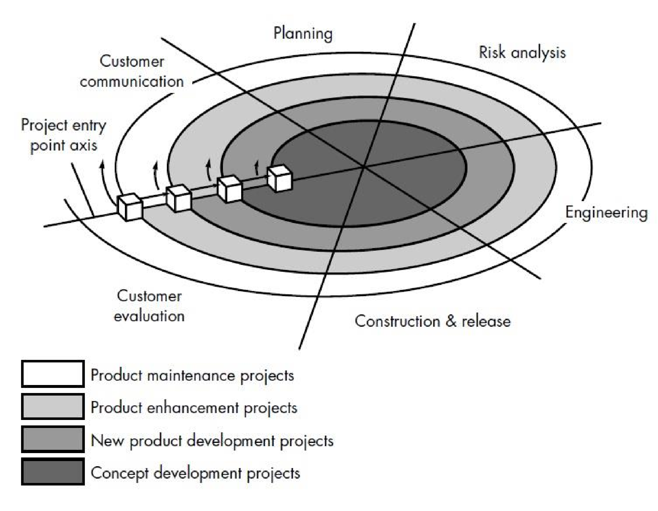

The Spiral model is an evolutionary software process model that couples the iterative nature of prototyping with the controlled and systematic aspects of the linear sequential model. It provides the potential for rapid development of incremental versions of the software. Using the spiral model, software is developed in series of incremental release.

A spiral model is divided into a number of framework activities, also called *task regions*. There are between three and six task regions. Figure depicts a spiral model that contains six task regions:

* Customer communication – tasks required to establish effective communication between developer and customer.
* Planning – tasks required to define resources, timelines, and other project related information.
* Risk analysis – tasks required to assess both technical and management risks.
* Engineering – tasks required to build one or more representations of the application.
* Construction and release – tasks required to construct, test, install, and provide user support.
* Customer evolution – tasks required to obtain customer feedback based on evolution of the software representations created during the engineering stage and implemented during the installation stage.

Each of the regions is populated by a set of work tasks, called a task set, that are adapted to the characteristics of the project to be undertaken. For small projects, the number of work tasks and their formality is low. For larger, more critical projects, each task region contains more work tasks that are defined to achieve a higher level of formality.

In our case, we have to provide medium level of formality for making a good project report. We will take decision about cost, schedule and number of iterations required to complete the software.

# 2.3 Project Plan

## Stages of Software Lifecycle

* **Software Requirement Analysis**

This is the first stage of the project, which involves interaction with the customer to understand his/her needs, requirements, information, required functions, performance and interfacing in MLM software. For this purpose requirement analyst will arrange a meeting for gathering information and additional details for software development. After completing requirement gathering tasks developer team will take a look for understand how requirements can be computerized. The requirement is documented in the form of a Software Requirement Specification (SRS) which is then presented to the customer for review.

* **Design**

Beginning once software requirements have been analyzed and specified, software design is the first of three technical activities – design, code generation, and test – that are required to build and verify the software.

Design is multi-level process which defines following details:

* + Data Design
  + Architecture Design
  + Interface Design
  + Component level Design

* **Development**

The design must be translated into a machine-readable form. The coding step performs this task. In this stage, the developers will actually code the programs. The specifications arrived at the design stage for each and every function will be converted to code using tools that are finalized for the implementation of the Software. At this stage the testing methodology to be adopted will be finalized. For each program test cases will be prepared and for each of these test cases, test data will also be prepared. The actual developers will do a first cur checking at this stage to see that the programs written by them are error free.

* **Testing**

In this stages the test group of the development team, using the cases and the test data already prepared will test the programs. Only after all the functions are tested singularly, an integrated testing will be performed to see that interfunction dependability is satisfied. Separate test cases and test data will be worked out for the integrated testing.

* **Acceptance Test**

This round of testing will be performed by the test group formed by the users of MLM software. This test group has to insure that the developed software is working as per their requirements. If some problems are found then it should be immediately communicated Development group so that the problem can be looked into and hence rectified.

* **Data Creation**

For software, data is most important part. Data is information which is handled by software. So before coding software, all master table data will have to be created.

* **Implementation**

Now the implementation of software is to be done by programmers. All the requirements and information gathered by the analyst is now take actual image in form of software. After making software it is uploaded in to the system so users, for whom software is developed, can use the software.

Once we examine that the project is feasible, we undertake project planning.

The table below describes how we planned our project.

# 2.4 Estimation

## Effort Estimation

Effort estimation methods are one of the important tools for project managers in controlling human resources of ongoing or future software projects. The estimations require historical project data including process and product metrics that characterize past projects.

Software cost and effort estimation will never be an exact science. Too many variables human, technical, environment, political can affect the ultimate cost of software and effort applied to develop it. However, software project estimation can be transformed from a black art to a series of systematic steps that provide estimate with acceptable risk. To achieve reliable cost and effort estimates, a number of options arise:

❖ **Software Sizing**

* Function point sizing
* Standard component sizing

❖ **Problem-Based Estimation**

LOC and FP data are used in two ways during software project Estimation:-

* As an estimation variable to size each element of the software and
* As baseline matrices collected from past projects and used in conjunction with estimation variables to develop cost and effort projections.

* **Schedules**

Obtain an early view of staffing requirements and constraints, and demonstrate the impact of changing deadlines, understaffing, and staff loading.

* **Quality**

Quantify the impact on defect rates of building to deadlines or reducing staff.

* **Risk**

Fine tune risk levels for all the major types of risk: size, requirements, technology, maintenance, systems integration, and defects.

# 3.0 System Requirements Study

**3.1 User Characteristics**

There are 3 types of user dealing with the system.

User A? Administrator

Administrator: Admin is having all the rights on the application.

User B? Employee

Employee: Employee of the company is one of the 3 users of this project

User C? Client

Client: This is the registered user. Who come to know about his/her project’s progress?

**3.2 Hardware and Software Requirement:**

## Hardware Specification:

Processor : Intel Dual based system

Processor Speed : 1GHz to 2 GHz

RAM : 256MB to 512 MB

Hard Disk : 4 GB to 30 GB

Keyboard : 104 keys

## Software Specification:

Language : Python 3.7

Database : Microsoft SQL Server 5.7.24.0

Operating System: Windows 7/8/8.1/10

RAM : 512 MB

**3.3 Constraints:**

## General Constraints

1. This system will not take care of any virus problem that might occur on the computer with which it is installed. Avoiding the use of pirated/illegal software and ensuring that floppies and other removable media are scanned for viruses before use could minimize the possibility of viral infection.
2. Recovery of data after a system crash will be possible only if backups are taken at regular intervals.

## Hardware Constraints

The performance of the system will be dependent on the machine conditions. The primary memory (RAM) and the secondary memory (Hard Disk Space) requirement of the system will be the same as that required by the normal application and the operating system. And the space required storing the data. The space required to store the data would increase as more and more records are added to the system.

## Assumptions and Dependencies

1. It is assumed that the user is familiar with the basic computer

fundamentals.

1. Timely backup of data should be taken to avoid data loss in case of

system crash.

1. Floppies and other removable media should be scanned for viruses

before use.

1. It is assumed that the maintenance of the database will be assigned to the authorized person only.
2. Only authorized persons will be allowed inside the system

# 4.0 System Analysis

**4.1 Study of Current System:** The current PiggyBank system falls short of controlling the client transaction and updating in the database. It is also very hard to find employees to handle the system and database due to complexity.

**4.2 Problem and Weaknesses of Current System**

* Not client/server based
* Need of extra manual effort.
* It is hard to handle database
* Not very much accurate.
* Danger of losing the files in some cases.

**4.3 Requirements of New System**

The new PiggyBank system requires only one Administrator to handle the database. The database is secure from external users and only Administrator and specified Employee above can access it. The proposed system of PiggyBank system is the right software to be incorporated into the Automation of PiggyBank Software for helping the bank needs with respect to handling transactions.

**ADVANTAGES OF PROPOSED SYSTEM:**

* Very fast and accurate.
* No need of any extra manual effort.
* No fever of data loss.
* Just need a little knowledge to operate the system.
* Doesn’t require any extra hardware device.
* A client/server system with a central database.

**4.4 FEASIBILITY STUDY:**

Once the problem is clearly understood, the next step is to conduct feasibility study, which is high-level capsule version of the entered systems and design process. The objective is to determine whether or not the proposed system is feasible. The following tests of feasibility have been carried out.

* Technical Feasibility
* Economic Feasibility
* Operational Feasibility

* **TECHNICAL FEASIBILITY**

In Technical Feasibility study, one has to test whether the proposed system can be developed using existing technology or not. It is planned to implement the proposed system using python technology. It is evident that the necessary hardware and software are available for development and implementation of the proposed system. Hence, the solution is technically feasible.

* **ECONOMIC FEASIBILITY**

As part of this, the costs and benefits associated with the proposed system compared and the project is economically feasible only if tangible or intangible benefits outweigh costs. The system development costs will be significant. So the proposed system is economically feasible.

* **OPERATIONAL FEASIBILITY**

It is a standard that ensures interoperability without stifling competition and innovation among users, to the benefit of the public both in terms of cost and service quality. The proposed system is acceptable to users. So the proposed system is operationally feasible.

# 5.0 Testing

Here APPLICATION works as main class. All other classes are related with this class.

APPLICATION does following operations:

**Reference:** Entering customer code represents inserting ATM card into ATM machine.

* Home window contains bank title with entry request where user have to enter customer code.
* If he/she is a registered user and customer code is correct, a new page with pin request to login and to do further operations. like:
  + Check Balance
  + Withdraw
  + Deposit
  + Transfer

# 5.1 The Welcome Page

If user is registered in the banking system from homepage they have to enter their customer code on the first page.

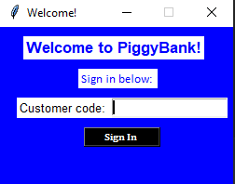

# 5.2 The Authentication Page

If the customer code exists in banking system database, a new login page displaying the customer name and a field to enter pin comes up.

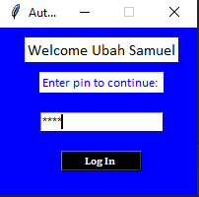

# 5.3 Transaction Page

The transaction page contains four options for the user they can choose what transaction they need to do.

* Check Balance
* Withdraw
* Deposit
* Transfer

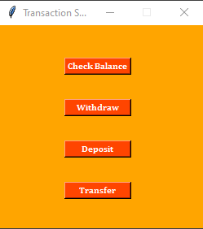

# 5.4 Check Balance Window

The check balance window displays the customer name and account balance.

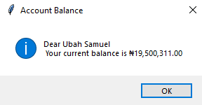

# 5.5 Withdraw Page

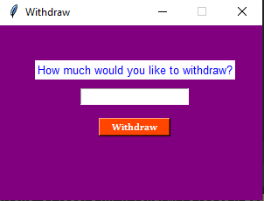

# 5.6 Deposit Page

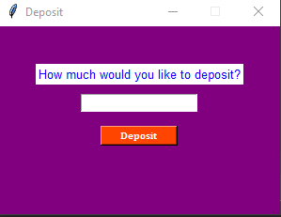

# 5.7 Recipient Page

Once the transfer button is clicked, the recipient page comes up with entry request for 10 digit recipient account number and recipient bank

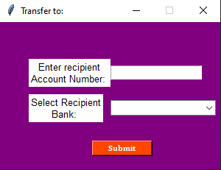

# 5.8 Transfer Page

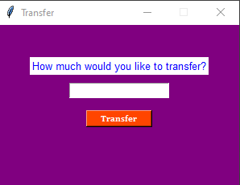

# 6.0 Limitation and Future Enhancement

**Limitation:**

* Although we have tried to add all the related features to this ATM Management System but there are also some limitation.

# 7.0 Conclusion

Back in 1969, Chemical Bank announced that a new form of banking was being launched. With that, customers were provided with plastic cards designed with a magnetic strip that could be used with a machine built into a wall. Gone were the days of having to stand in line for a teller or not having money on hand after normal banking hours. Almost everyone has heard of and used an ATM machine. Interestingly, some of people feel that ATM machines are the best thing to happen in the banking world while other people consider them a curse. The main complaint heard about ATM machines is that while they are convenient, they are expensive to use. However, if we look at it from a banking perspective, business is business.

Regardless of what we think of ATM machines, there is no doubt that they have changed the world and the way in which we do things. For example, think how many times we have been out somewhere only to discover we have no cash and we are out of checks, ah, but in the corner, there is an ATM machine. In the blink of an eye, we swipe the card and now have cash on hand. In addition to pulling money out, the ATM machine also makes it convenient to deposit money, transfer money, and check balances. Best of all, to use an ATM machine, we do not have to go to the bank. We will find ATM machines at other banks, grocery stores, shopping malls, along the roadside, Buckingham Palace, airports, in casinos, and even on the South Rim of the Grand Canyon. For this reason, ATM machines are extremely helpful!